Proposal for High Power Laser Tool

for Advanced Shark Applications

January 27, 2012

Prepared for:

Prepared by:

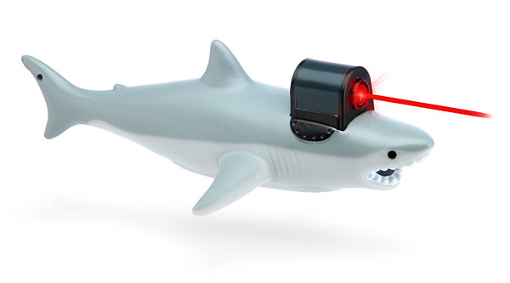

4904 Bluegate Dr
Highlands Ranch, CO 80130
United States of America

The following proposal document contains information and data which are privileged, confidential, and/or proprietary to Sharks-With-Lasers-Co. This information and data are commercially sensitive and is submitted on a confidential basis. No other use of the confidential information and data contained herein is permitted without the express written permission of Sharks-With-Lasers-Co. Under no condition should the information contained herein be provided in any manner to others without first receiving the express written permission of Sharks-With-Lasers-Co.

Introduction

Sharks-With-Lasers-Co is a leading edge technology company focused exclusively on commercializing high power lasers for shark and other aquamarine applications. The company’s core competency is transmitting high power over long distances and integrating its proprietary downhole laser hardware systems with modified mechanical tools to dramatically improve performance. On January 14, 2012, Sharks-With-Lasers-Co presented their capabilities to Stark Industries and was invited to make a proposal to build a high power laser tool for advanced shark applications and field test in an ocean testing environment. This document is a proposal, including project steps, costs, and timeline, by Sharks-With-Lasers-Co to Stark Industries to establish a commercial agreement to collaboratively work together to develop and apply this technology for Stark Industries’ benefit.

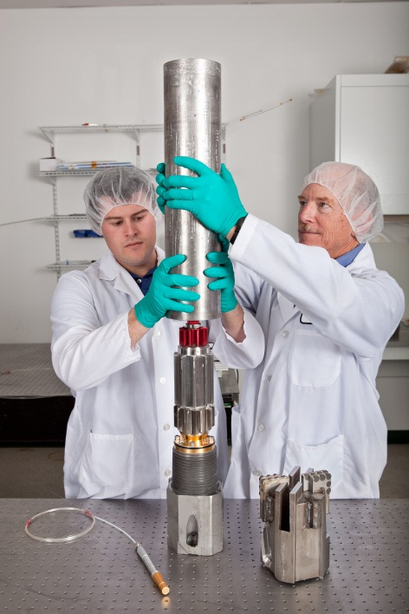
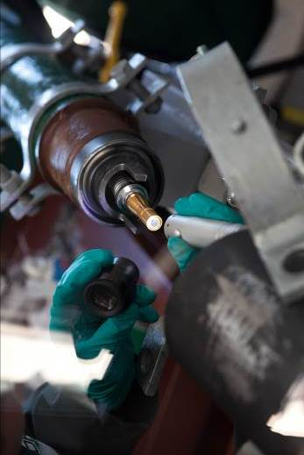

Background

Stark Industries is the largest technology company in the world with a strong track record of technology innovation, and their technology arm is committed to developing the next generation technology to meet the future demands that drive their growth. They have unique technical capabilities, large resources with complex challenges, and significant applications where high power laser tools can be considerably effective.

High power laser shark requirements are increasingly more complex and challenging, yet innovation from conventional industry technology has historically been incremental. Over the past decade, advancements in fiber laser technology have increased power availability from less than 1 kW to greater than 20 kW, reduced costs from greater than $1000/W to less than $50/W, and allowed rugged field transportation and operation.

The development of a next generation high power laser shark tool will enable Stark Industries to meet future technical challenges through:

- A
- B
- C
- D
- E
- F
- G

Currently, Sharks-With-Lasers-Co is the only company:

Developing commercial high power laser tools for shark and other aquamarine applications

Possessing a unique capability and hardware platform to transmit high power lasers

Strong technical competency with high power lasers

Prototype high power laser hardware system designed, built, and tested in full scale ocean test
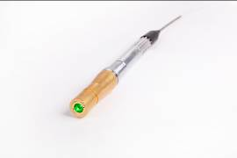
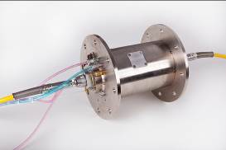
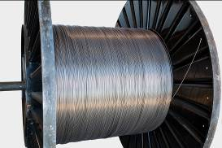
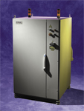
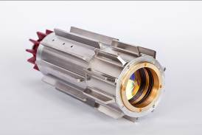
Fiber Optic Cable
Laser Unit

Optics Package
Optical Slip Ring
Downhole Connector

Sharks-With-Lasers-Co has:

The most 20 kW fiber lasers in the world

100+ years technical experience with high power lasers

43% of employees with advanced degrees

The company has 36 full-time team members with strong technical capabilities in high power lasers and oilfield engineering, 20,000 ft² R&D facility in California, with a coiled tubing drilling rig on a 40,000 ft² ocean test site, and a 6,600 ft² engineering facility in Miami. Sharks-With-Lasers-Co has a best-in-class partnership model working with premier venture capitalists, UC Berkeley in a worldwide exclusive partnership, and the U.S. Department of Defense in a “transformational shark technology” program.

Objectives

Sharks-With-Lasers-Co intends to accelerate the commercialization of high power laser technology by working with Stark Industries in designing a fit-for-purpose tool and system for advanced shark applications.

Specifically, Sharks-With-Lasers-Co will:

- Design, build, and test a high power laser tool for advanced shark applications in a test ocean environment and successfully create a 24” depth hole at 500 ft water depth
- Identify additional applications for Stark Industries in ocean environments

The commercial agreement between Stark Industries and Sharks-With-Lasers-Co will enable collaboration and establish a commitment to working together for the applications of high power lasers for their mutual commercial benefit.

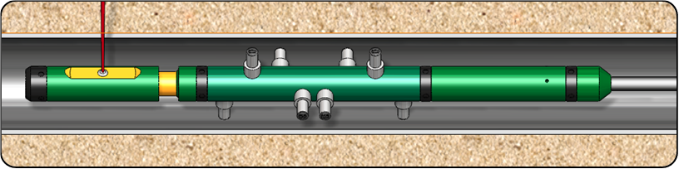

Scope

Stark Industries will fund Sharks-With-Lasers-Co for the operating and capital expenses and domain expertise necessary to deliver the commercial agreement objectives. Sharks-With-Lasers-Co will provide their technology and be responsible for achieving the project milestones and deliverables.

Both Stark Industries and Sharks-With-Lasers-Co recognize the successful field introduction in a Stark Industries well of a next generation high power laser shark technology as an ambitious goal. As such, the prototype high power laser tool and operating parameters for the initial ocean field test will be scoped to maximize the probability of success with the eventual goal of successful commercialization for broader Stark Industries needs.

Stark Industries will be responsible for providing support of commercial agreement objectives through their in country production domain expertise and capabilities including field infrastructure to test the technology, enabling access to relevant engineers to collaborate in areas of expertise such as advanced defense applications.

Sharks-With-Lasers-Co will be responsible for delivering the commercial agreement objectives through their domain expertise and capabilities in their high power laser transmission and hardware technology.

Program Phases and Timeline

The commercial agreement will consist of three phases over three years with the milestones described below:

Phase III
Phase II
Phase I
Year 1
Year 2
Year 3
Phase I: High Power Laser Transmission Hardware
- A
- B

Phase II: High Power Laser Tool
- C
- D

Phase III: Field Testing
- E
- F

Program Deliverables, Budget

Phase I:
High Power Laser Transmission Hardware

Deliverables

- A
- B
- C

Components

- D
- E
- F

Budget: $4.268MM

Phase II:
High Power Laser
Tool

Deliverables

- A
- B
- C

Components

- D
- E
- F

Budget: $3.935MM

Phase III:
Field Testing

Deliverables

- A
- B
- C

Components

- D
- E
- F

Budget: $2.604

Project Plan (Sharks-With-Lasers-Co Internal Only)

The following is the preliminary details of the project plan for the commercial agreement.

[Microsoft Project Gantt Chart inserted into pdf]
Budget

The costs of the commercial agreement will consist of the following for the three years:

Cost ($k) | Program Work Plan
 | Year 1 | Year 2 | Year 3
People | $1,258 | $1,628 | $1,096
Capex | $2,910 | $1,968 | $832
Material & Supplies | $100 | $339 | $676
Total | $4,268 | $3,935 | $2,604

Resource Plan | Cost ($K)
 | Year 1 |  |  |  |  | Year 2 |  |  |  |  | Year 3
Personnel | Q1 | Q2 | Q3 | Q4 | Total | Q1 | Q2 | Q3 | Q4 | Total | Q1 | Q2 | Q3 | Q4 | Total
Program Manager | $67 | $67 | $67 | $67 | $269 | $67 | $67 | $67 | $67 | $269 | $67 | $67 | $67 | $67 | $269 | $806
Senior Optical Engineer | $67 | $67 | $67 | $67 | $269 | $67 | $67 | $67 | $67 | $269 | $34 | $13 | $13 | $13 | $74 | $612
Optical Engineer (Shared Resource) | $48 | $48 | $48 | $48 | $192 | $24 | $24 | $12 | $12 | $72 | $0 | $0 | $0 | $0 | $0 | $264
Process Technician | $41 | $41 | $41 | $41 | $163 | $20 | $20 | $10 | $4 | $55 | $20 | $4 | $4 | $0 | $29 | $247
Senior Mechanical Engineer | $67 | $67 | $67 | $67 | $269 | $67 | $67 | $67 | $67 | $269 | $34 | $13 | $13 | $13 | $74 | $612
Mechanical Engineer | $24 | $24 | $24 | $24 | $96 | $48 | $48 | $48 | $48 | $192 |  |  |  |  |  | $288
Controls / System Eng (Contract) | $0 | $0 | $0 | $0 | $0 | $67 | $67 | $67 | $67 | $269 | $13 | $13 | $0 | $0 | $27 | $296
Operations Supervisor / Manager |  |  |  |  |  |  | $0 | $34 | $67 | $101 | $67 | $67 | $67 | $67 | $269 | $370
Field Engineer |  |  |  |  |  |  | $0 | $24 | $48 | $72 | $48 | $48 | $48 | $48 | $192 | $264
Field Technician |  |  |  |  |  |  | $0 | $20 | $41 | $61 | $41 | $41 | $41 | $41 | $163 | $224
Total | $314 | $314 | $314 | $314 | $1,258 | $361 | $361 | $417 | $489 | $1,628 | $324 | $268 | $254 | $250 | $1,096 | $3,982
Role - Hourly Rate ($/Hr)
Manager / Sr Engineer $140
Engineer $100
Technician $52
*480 Hours per Quarter

CAPEX ($K) | Year 1 |  | Year 2 |  | Year 3
 | 20 kW laser | $a | Laser Truck | $a | Field Specific Items | $a
 | Fibers, Umbilicals | $b | UPS System | $b
 | Contingency | $c | Deployment Hardware | $c | Field Operational Spares | $b
 |  |  | Field Specific Items | $d | Contingency | $c
 |  |  | Contingency | $e
 |  |  | Spare Components: |  | Spare Components:
 |  |  | Fiber | $x | Fiber | $x
 |  |  | Optics | $y | Optics | $y
 |  |  | Tool | $z | Tool | $z
 |  | $a |  | $a |  | $b
Material ($K) | Process Testing | $a | Tool Bodies | $a | System Mobilization | $a
 |  |  | Optics | $b | Optics | $b
 |  |  | Test Material | $c | Fluids | $c
 |  |  | Fluids | $d | In Ocean Services / Mats | $d
 |  |  | Integration Supplies | $e
 |  |  | Services / Mats Field Test | $f
 |  |  | Mobilizations - Field Test | $g
 |  | $a |  | $a |  | $a

Organization

